Bangladesh Akihiro Shiroshita

I observed CMC hospital from 8/9/2014-3/10/2014 for 4 weeks. Mainly, I learned about infectious diseases. To tell the truth, at the first visit I was confronted with the medical disparity between Bangladesh and Japan, especially hygiene. But I experienced the ward round, and noticed how sophisticated their clinical skills were. And I was touched by their efforts to improve it more. They’re studying very hard. I’m ashamed of our laziness. In Japan, we medical students don’t have enough chances to see the patients. Mostly, we’re just observing the daily clinical site. But CMC students have many cases and good quality educations. They can practice many procedures to the real patients. Japanese doctors are too much dependent on advanced instruments. We lack the foundation of physical examinations. Bangladesh keeps a good balance between duty and right. For example, they have to write the clinical chart only very shortly. It is very efficient. They have extra time to see other patients. In Japan, there are many law suits. So students’ roles have to be limited. Sometimes, I envy them. In addition, they are very good at English. We’re studying medicine only in Japanese, so sometimes I feel chagrin because I couldn’t discuss fluently with CMC students.
In summary, there are many things to learn in Bangladesh. I noticed the fact of my ignorance not only about medicine but also about my own country. I could reconsider medicine from the beginning. Japanese medicine is too specialized, so when we are faced the unforeseen disaster, we can’t cope with it. To cope with the natural disaster, we have to learn primary care more and more. CMC doctors educate their students the knowledge which is useful on the clinical site, not in the conference room. I really appreciate this exchange program.
In the daily life, I was really moved by their hospitality. Many teachers invited me to the dinner and many students talked with me a lot. I could exchange the information between Japan and Bangladesh. Sometimes I was confronted my ignorance about my own country. Sometimes, I was surprised at the difference of sense of values. But , I could made many many good friends. I will treasure our friendships forever. I really enjoyed the meal. I’ve never eaten such tasty curry. When I ate it with my hands, it got more delicious. Even now, I miss their curry and traditional food. I bought some spices for my souvenir and tried to cook curry in Japan. But I couldn’t reproduce the taste.
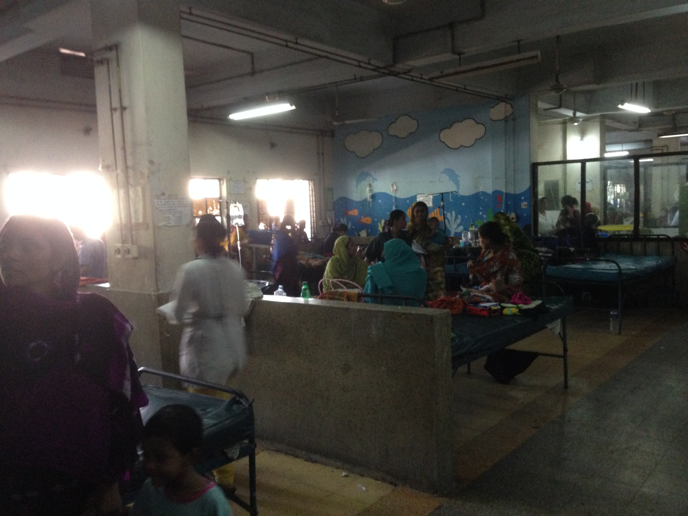
Through the exchange program, both Kobe University students and CMC students learn good things and bad things each other. I hope more and more Japanese students will go to Bangladesh and be exposed to the culture. Thank you so much for Principal Selim and everyone in CMC, my adviser Nick.
